Yours faithfully,

For C&J Gulf Equipment Manufacturing LLC.
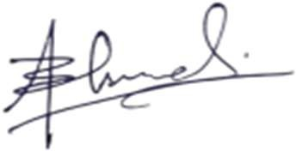

Bilal Ahmed
Cost & Estimation Engineer.
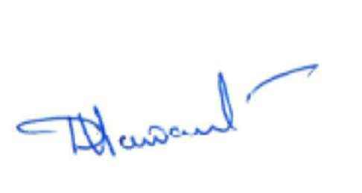
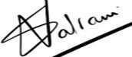

Datta C. Sawant Subash Valrani
Sr. Mechanical Engineer Business Unit Head

